VARUN BHARGAVA – 241010282
DATA STRUCTURES TASK-7

Task 01: Queue:
(https://github.com/varunnnb/dsa-sem3-iiitnr/blob/main/lab7/lab7-1.c)
Use a queue to convert a given positive integer into its binary representation.
Steps:
1. Input a decimal number (e.g., 19).
2. Repeatedly divide the number by 2, store remainders in a queue.
3. Dequeue elements to print the binary equivalent.

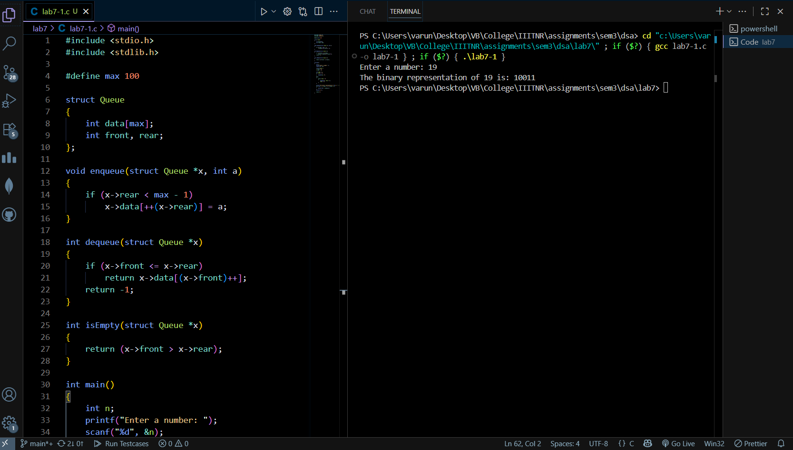
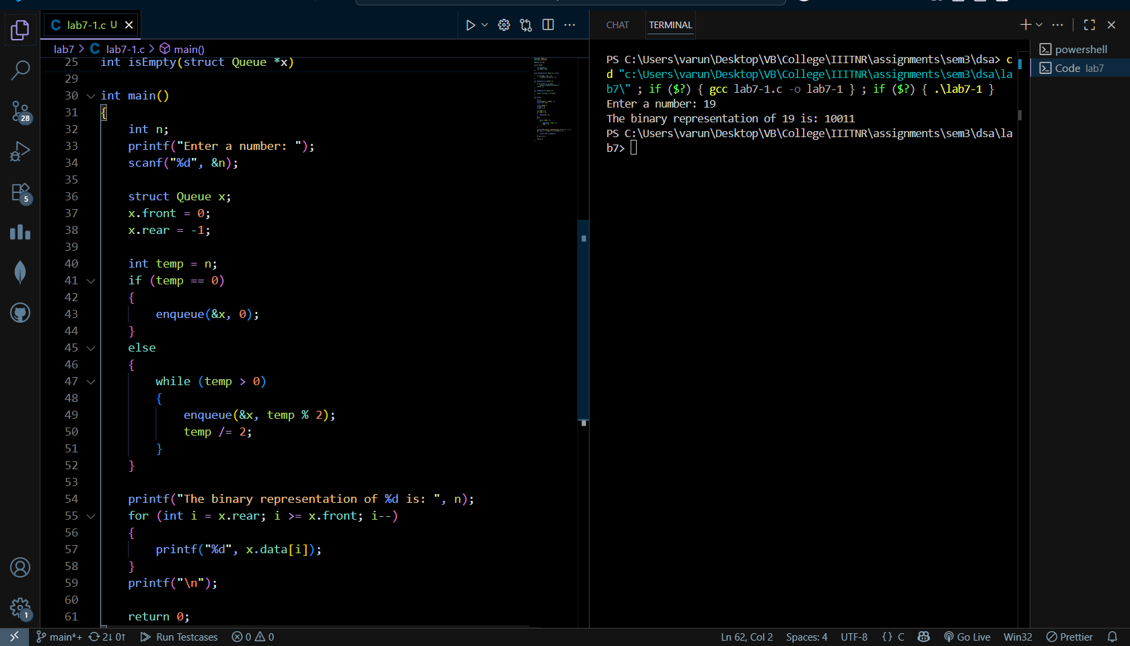

Task 02: Doubly Linked List:
( https://github.com/varunnnb/dsa-sem3-iiitnr/blob/main/lab7/lab7-2.c)
- Use a doubly linked list to add two large integers (each digit as one node).
- Steps:
- 1. Store each digit of the two numbers in separate doubly linked lists.
- 2. Perform addition digit by digit from the rightmost (using backward traversal).
- 3. Handle carry properly and display the result list.
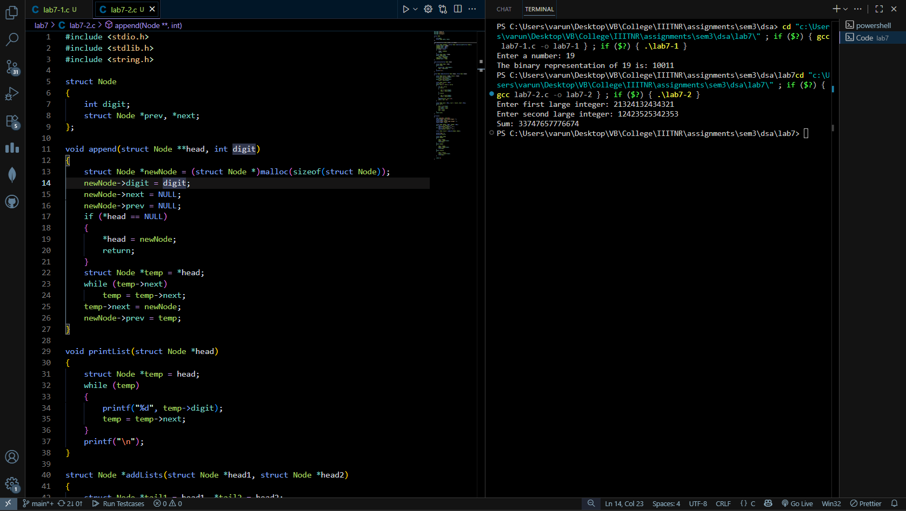
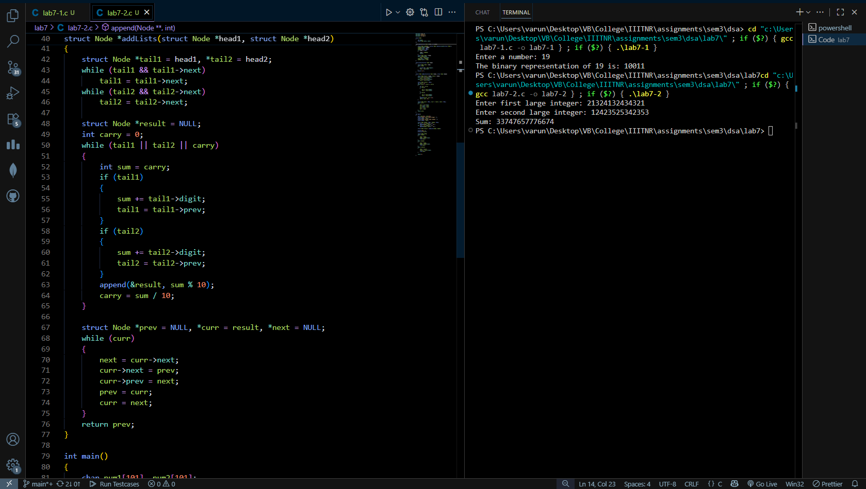
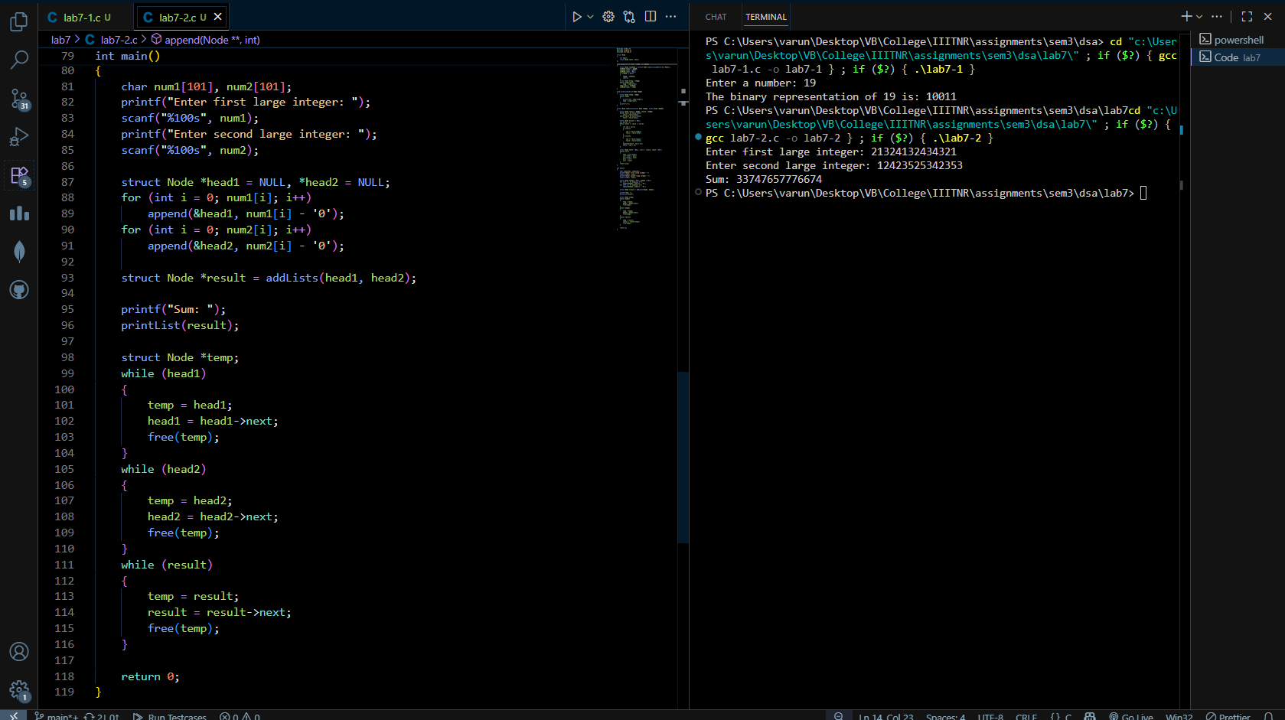

Task 03: Circular Doubly Linked List:
( https://github.com/varunnnb/dsa-sem3-iiitnr/blob/main/lab7/lab7-3.c )
Use a circular doubly linked list to represent and add two polynomials.
Steps:
1. Each node contains: coefficient, power, and links (prev, next).

2. Insert terms of the two polynomials.
3. Traverse circularly and add like terms (same power).
4. Print the resulting polynomial in decreasing order of power.
Example:
Polynomial A: 3x^3 + 4x^2 + 2( in CDLL 1)
Polynomial B: 5x^3 + 2x + 1( in CDLL 2)
Compare the power while traversing the list and add the sum in result list along
with power and display the final result.
Result: 8x^3 + 4x^2 + 2x + 3
